Setting> Scale:

The scale options are working fine.

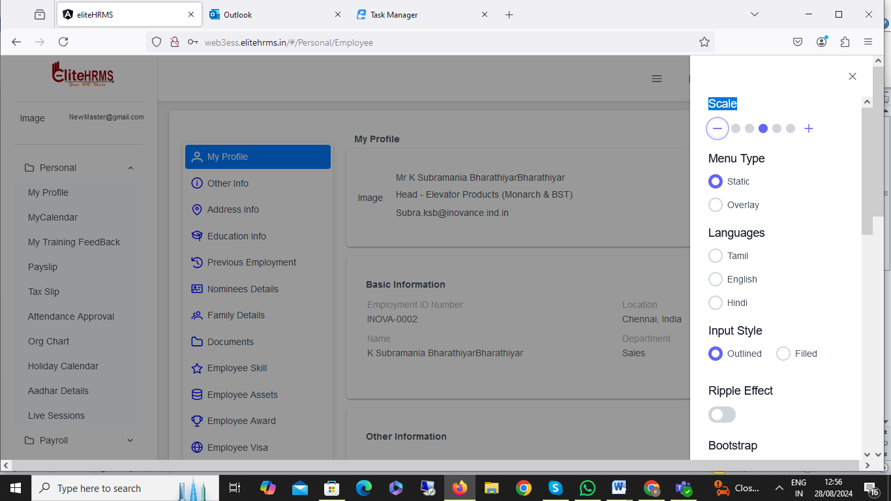

Setting> Menu Type

The Menu type options are working fine.

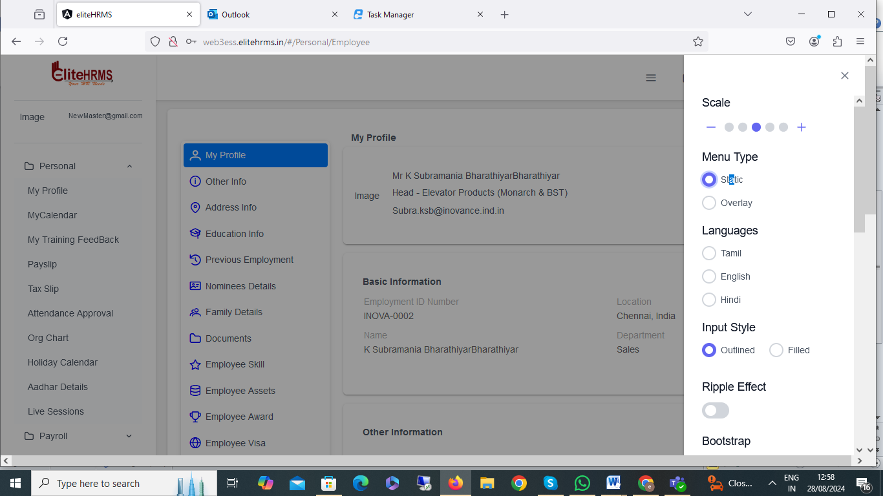

Setting> Languages
I have changed language details, not changed languages. Please check.

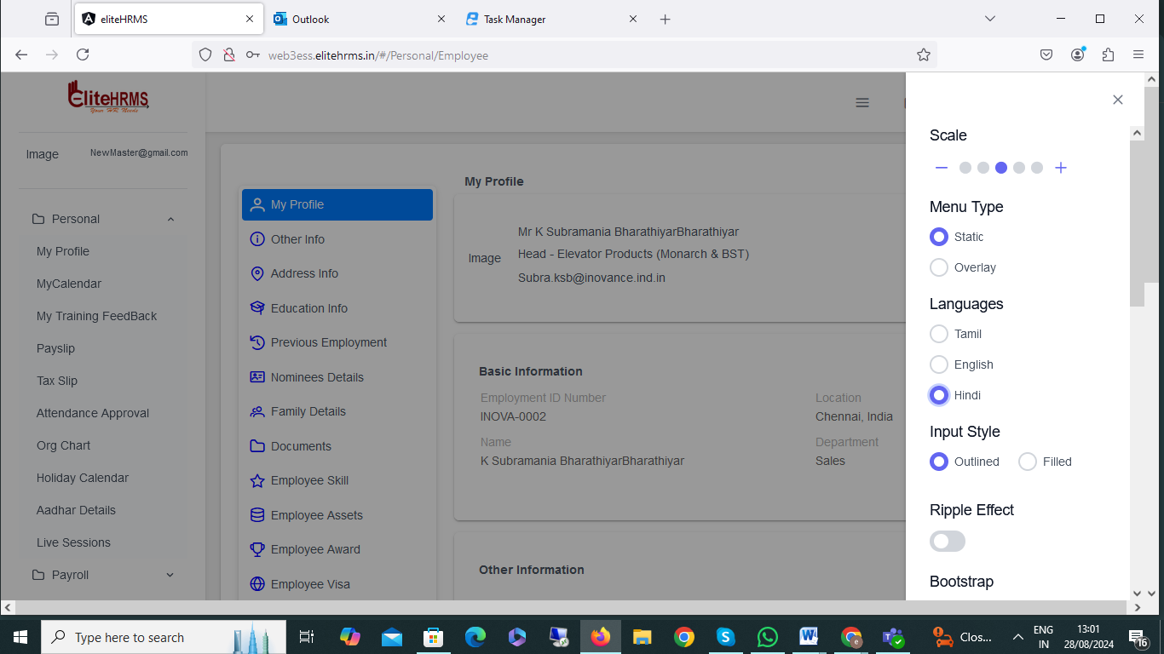

4. Setting > Input Style
Input style options are not working.

5. Personal>My profile:

The image load options are very small; please increase the size. And image not visible, please check.

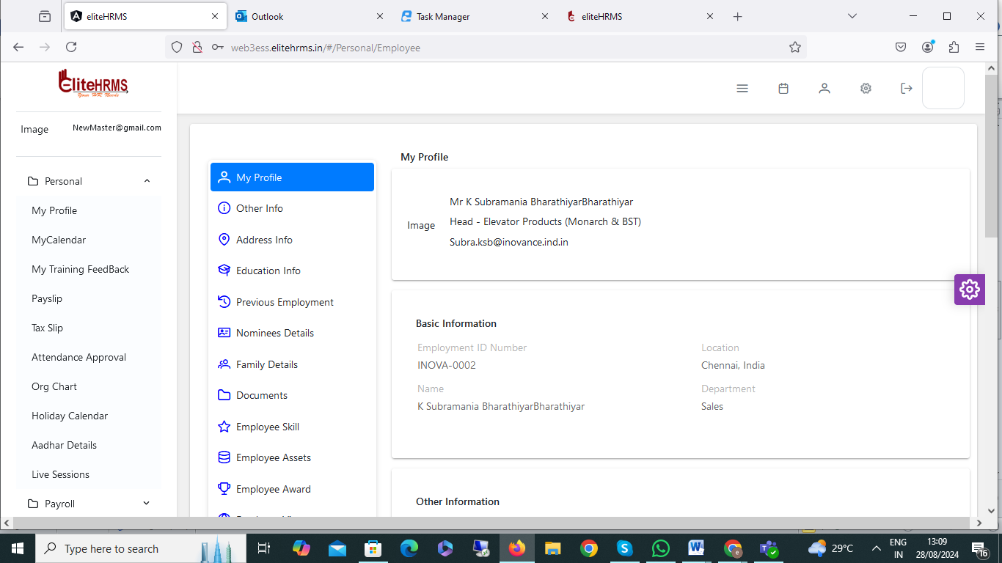

6. Personal>Basic Information:

The personal information details some details missing below mentioned, please check.
- Mode of Employment,2. Employment Type,3. Employment Category
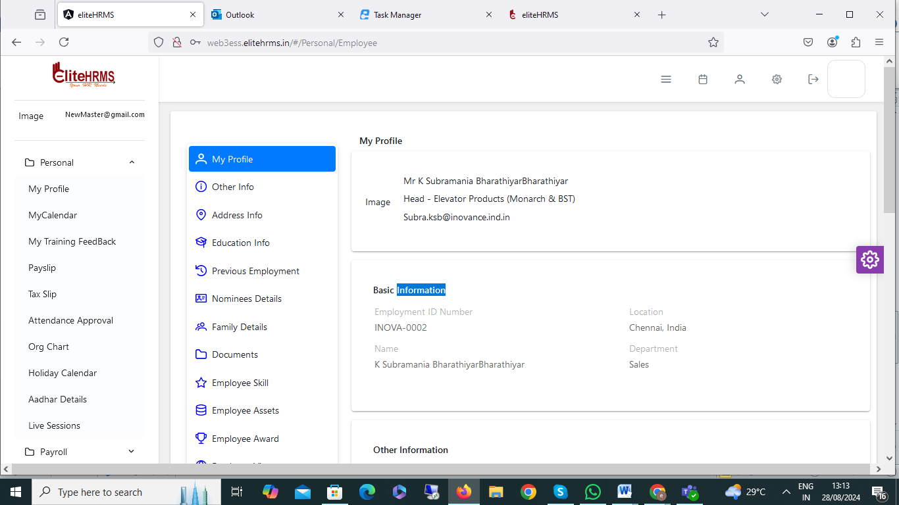

7. Personal >Personal Information:
I have changed the Personal Information Details record to add a successfully message. The problem is that the data is not showing and the display is not showing for the pending pop-up.

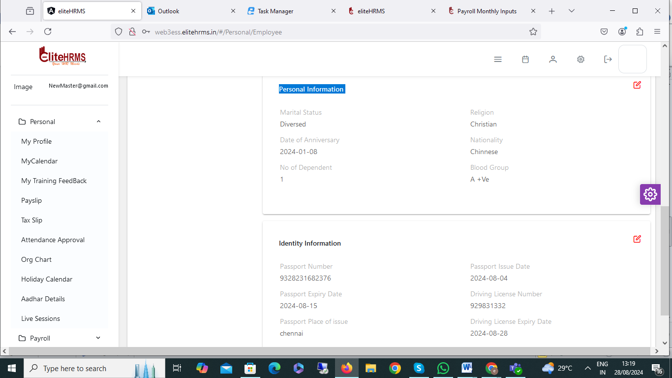

8. Personal > Identity Information:

I have changed the Identity Information Details record to add a successfully message. The problem is that the data is not showing and the display is not showing for the pending pop-up.
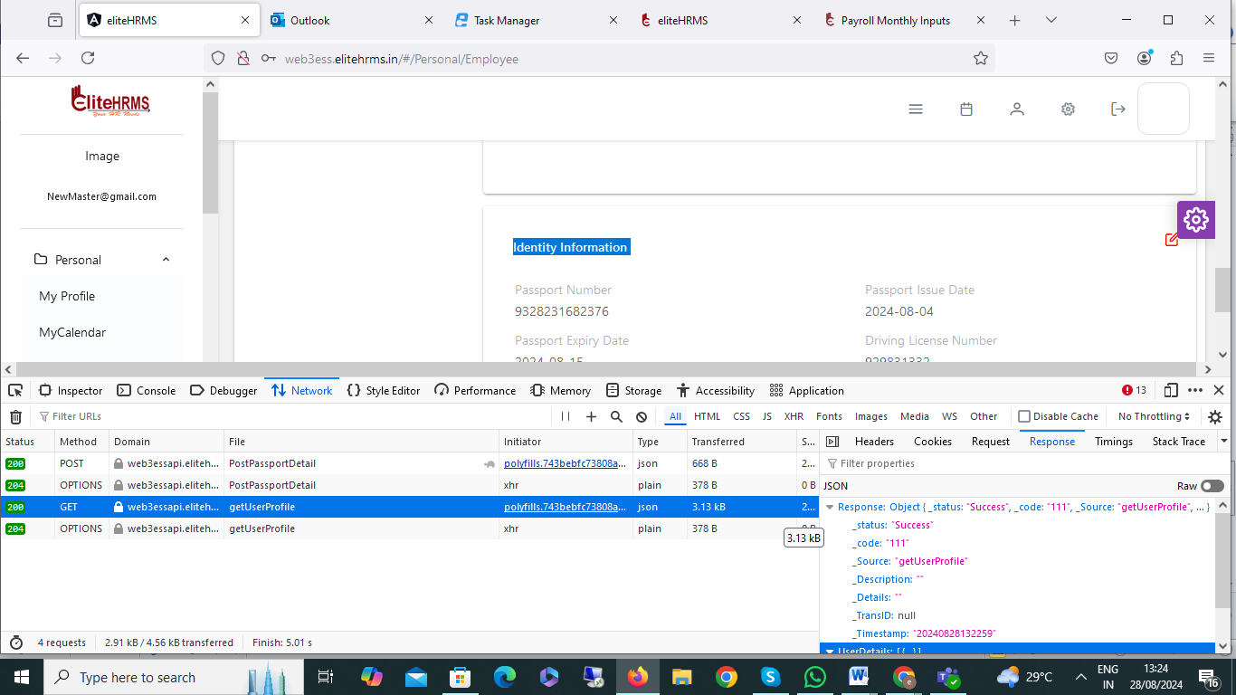

9. Other Info >Statutory Information:

The employee Pf details are available for the back office, but the other details (statutory information) are not showing. Please check.

Back office Screen:
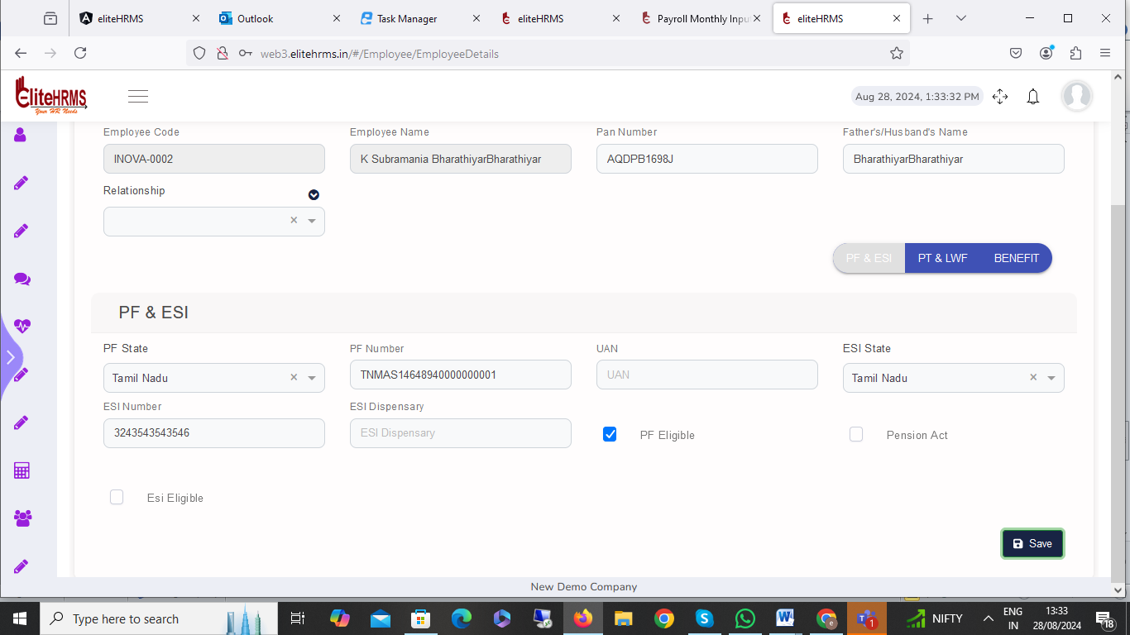

Ess Screen:

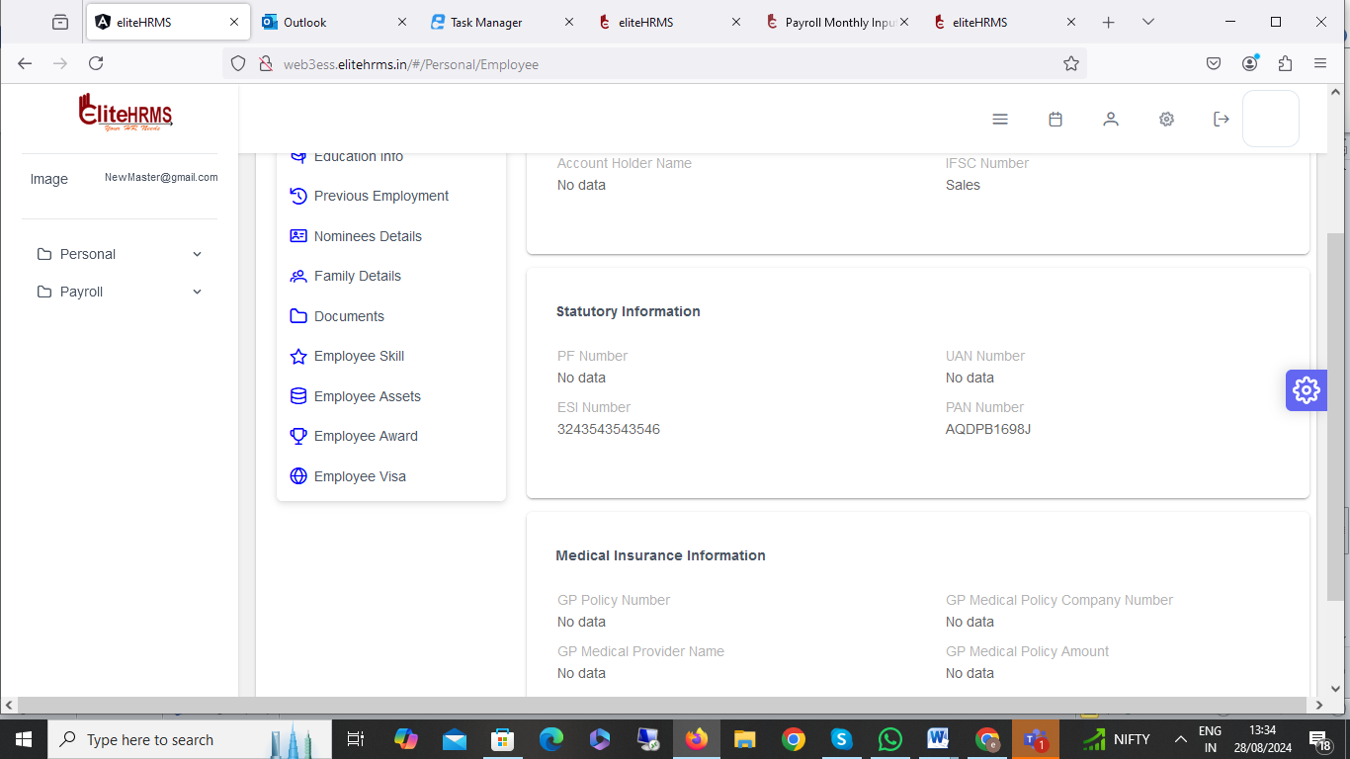

10. Address Info> Present Address:

I have changed the Present Address record to add a successfully message. The problem is that the data is not showing and the display is not showing for the pending pop-up.

Ess Screen:

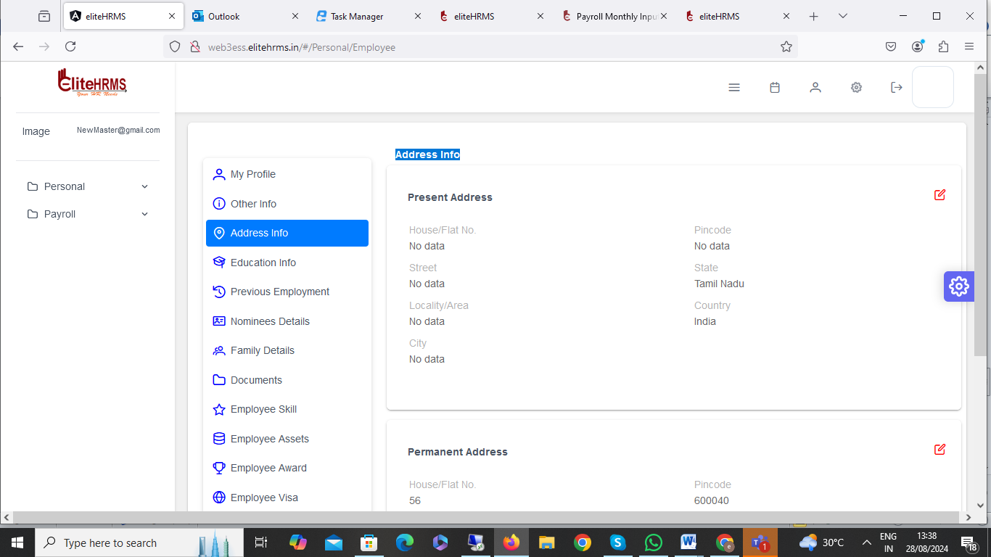
Back Off Screen:
I have added the address details back office; those details do not show for the ESS portal.

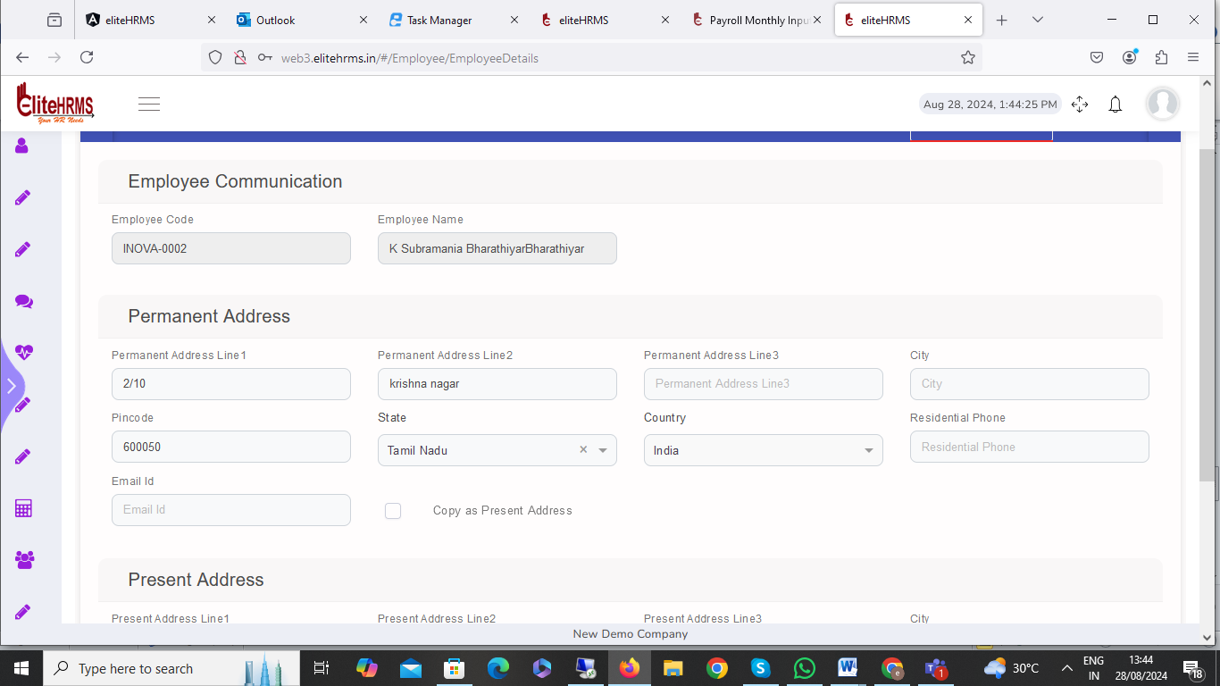

11. Permanent Address:

I have changed the Permanent Address record to add a successfully message. The problem is that the data is not showing and the display is not showing for the pending pop-up.

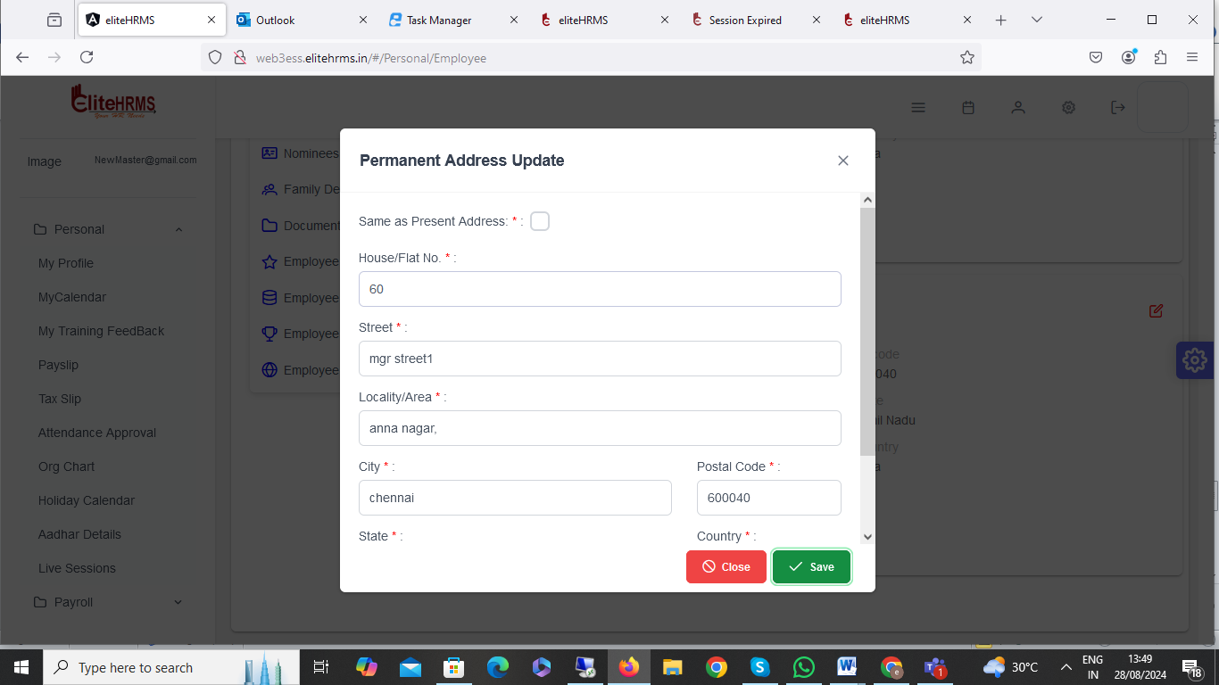

12. Education Info:

Education Info screen add and modified record save option is working fine, but the problem is that once the record delete button is clicked, it shows the error message. Please check.

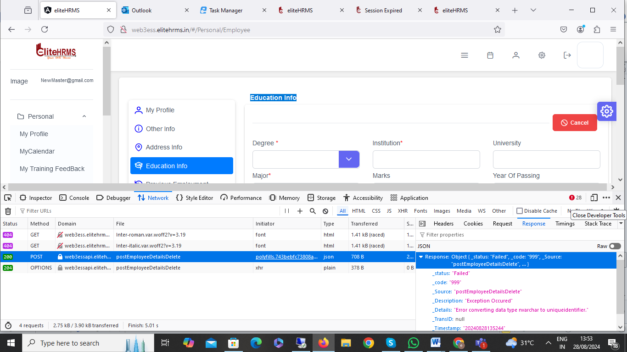

13. Previous Employment:
Previous employment record details added no issue; Problem is from period, and To period mentioned but not automatically calculated experience year.
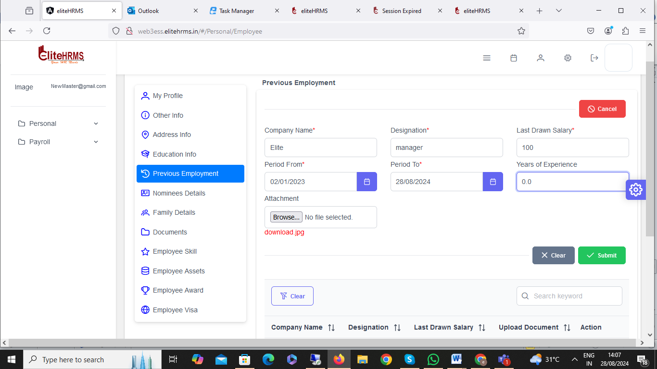

14. Employee Nominees:

Nominee Details back office screen data is available, but ess portal data showed.
Back office additionally, my entry data for the ESS Portal is not displayed.

Back office screen:

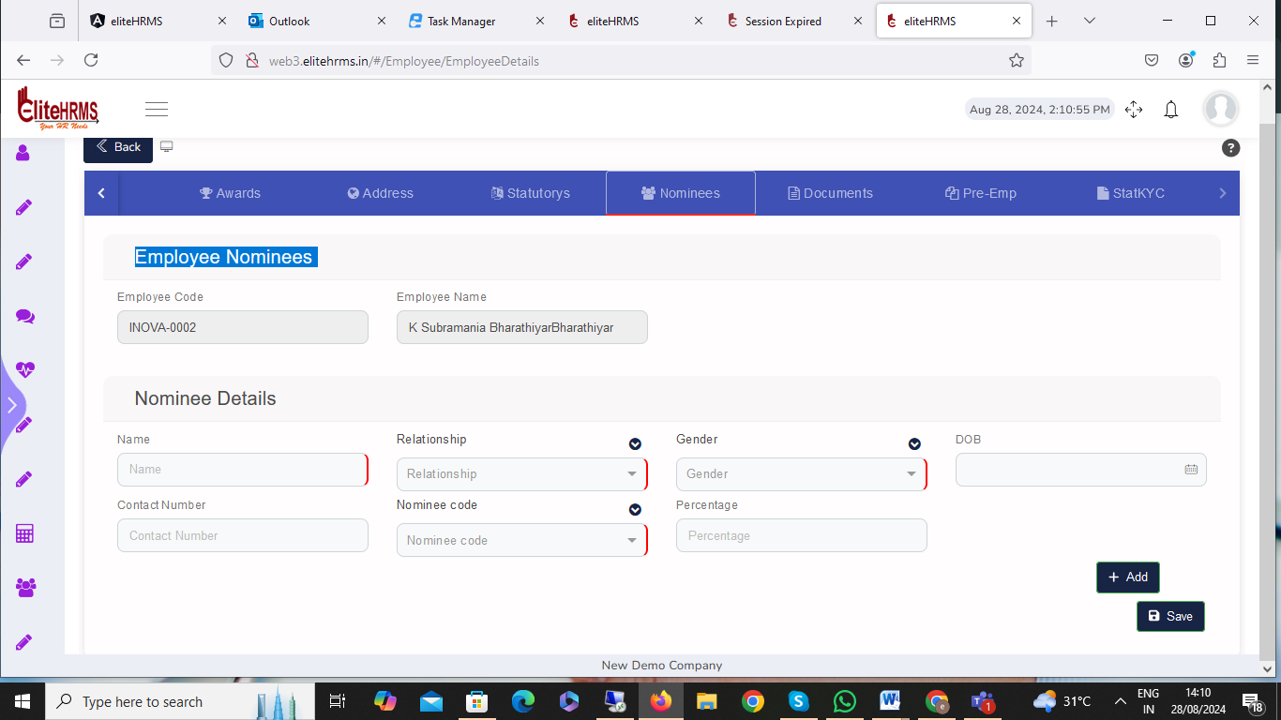

Ess Screen:

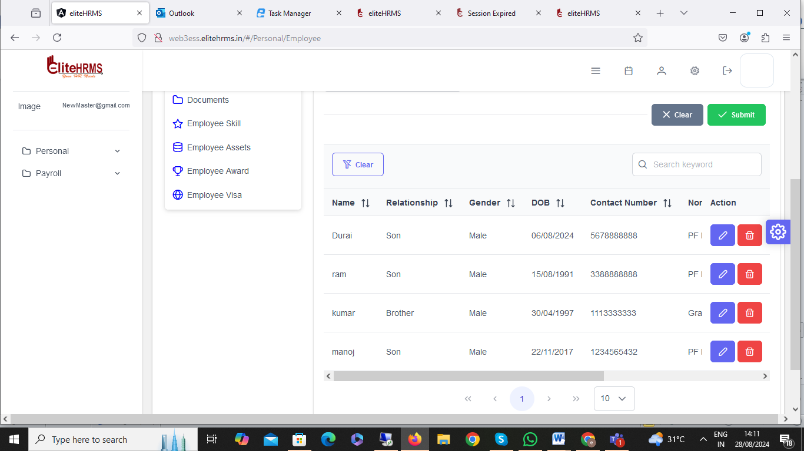

15. Family Details:

Back office screen:

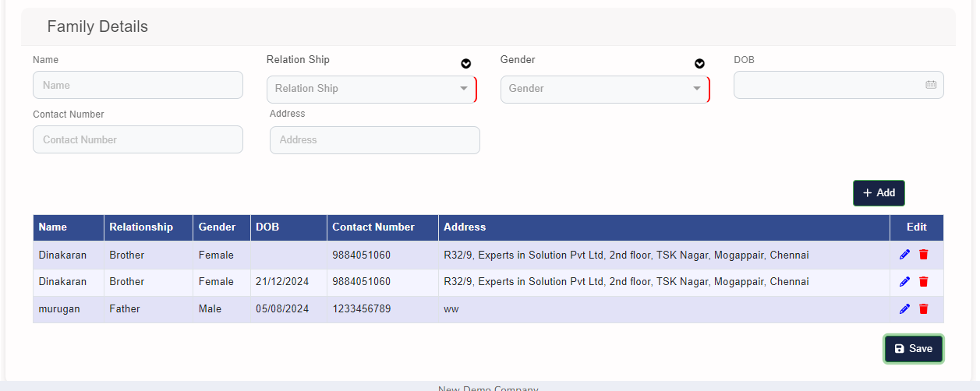

Ess Screen:

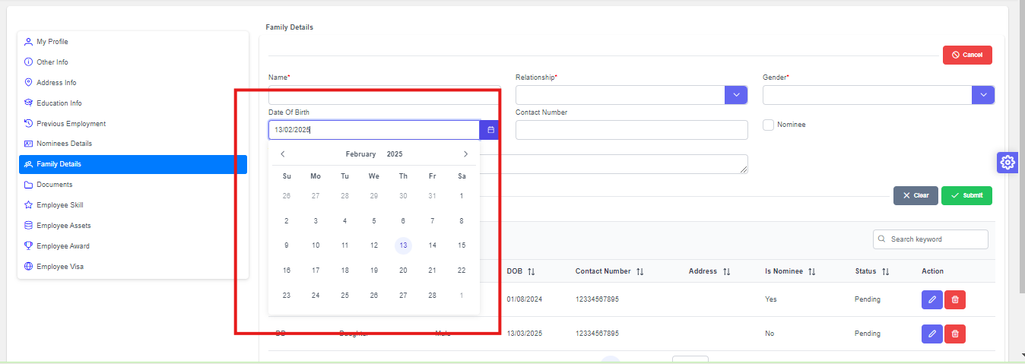

- ESS Request Records is not show Back office Records
- ESS Re login only to load the Data in the ESS
- DOB is Not Allowed Date Future Date, but the System is Acceptable - New Point
- The message is incorrect when the request record is deleted
- Back office additionally, my entry data for the ESS Portal is not displayed ( At time)

16. Document

Back office screen:

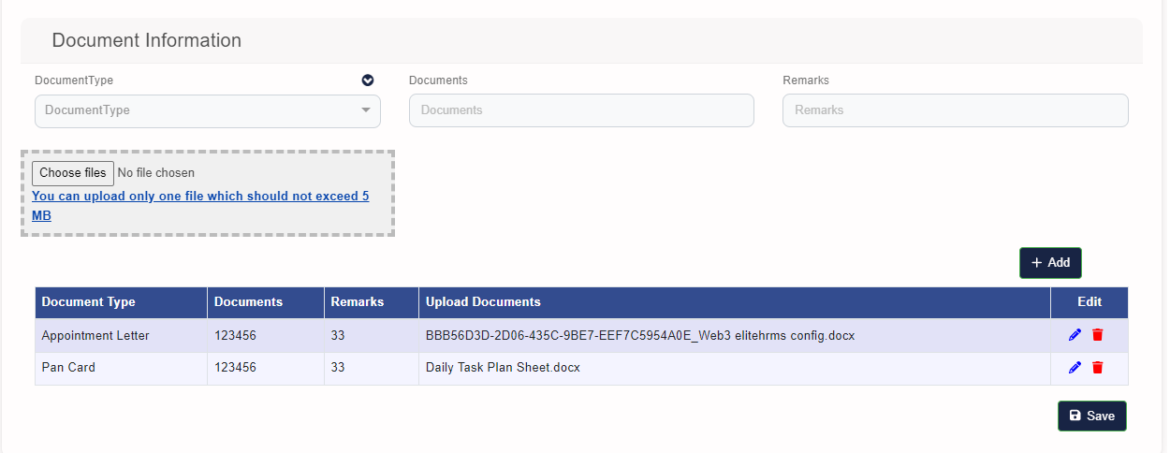
Ess Screen:

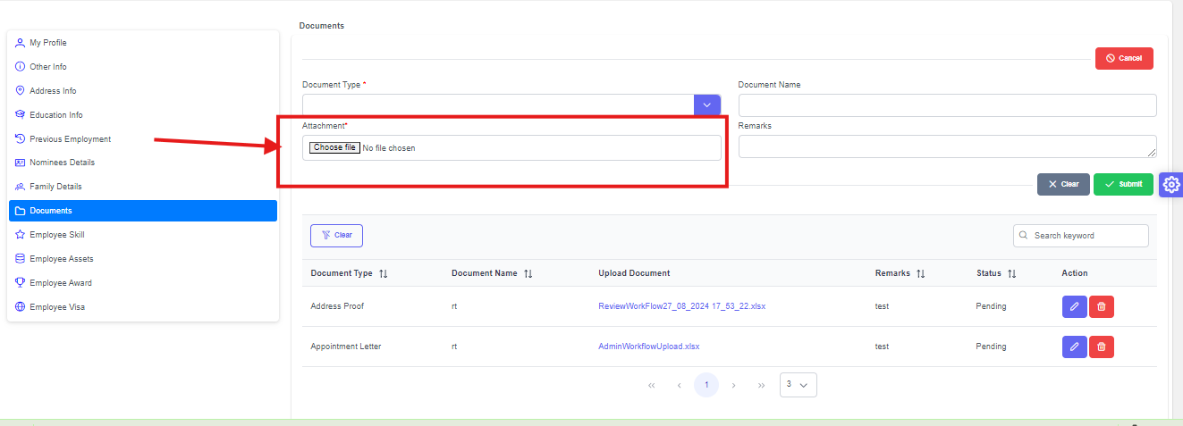
- Attachment file Size and File Type Information Required
- Attachment File Size must Fixed Setting Required
- Attachment File Type must Fixed Setting Required
- Attached document. If you have a unique number, request validation. Savings are required. Example Aadhar Document for Aadhar number.
- Back office additionally, my entry data for the ESS Portal is not displayed ( At time)

17. Employee Skill

Back office screen:
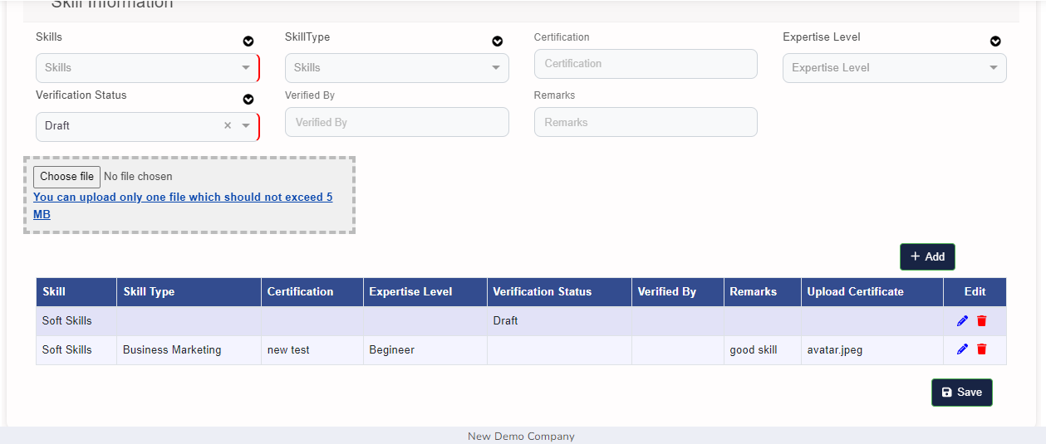
ESS Screen

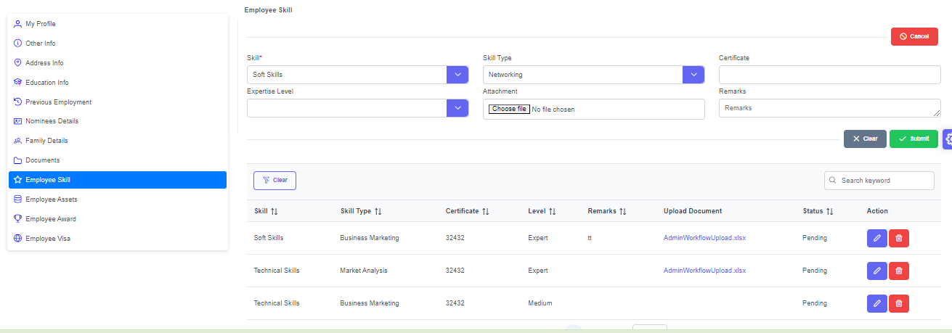

- Attachment file Size and File Type Information Required
- Attachment File Size must Fixed Setting Required
- Attachment File Type must Fixed Setting Required
- Back office additionally, my entry data for the ESS Portal is not displayed ( At time)

18. Employee Assets

Back Office Screen

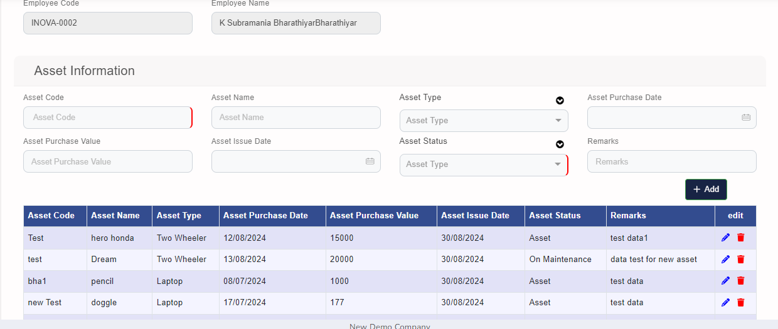

ESS Screen

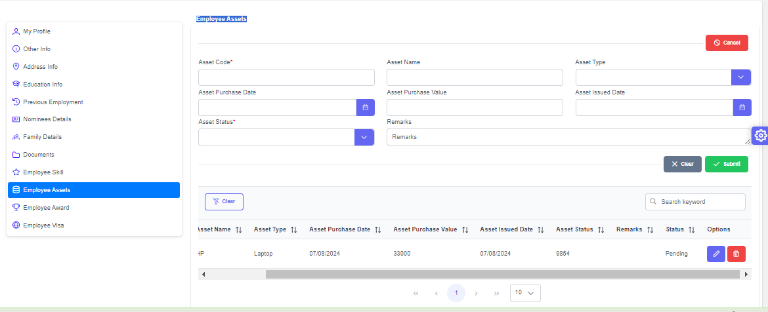
- Search Page not working
- Asset Status to show ID
- Back office additionally, my entry data for the ESS Portal is not displayed ( At time)
- Asset Code Drop down Data required – New Point

19. Employee Award
Back office Screen
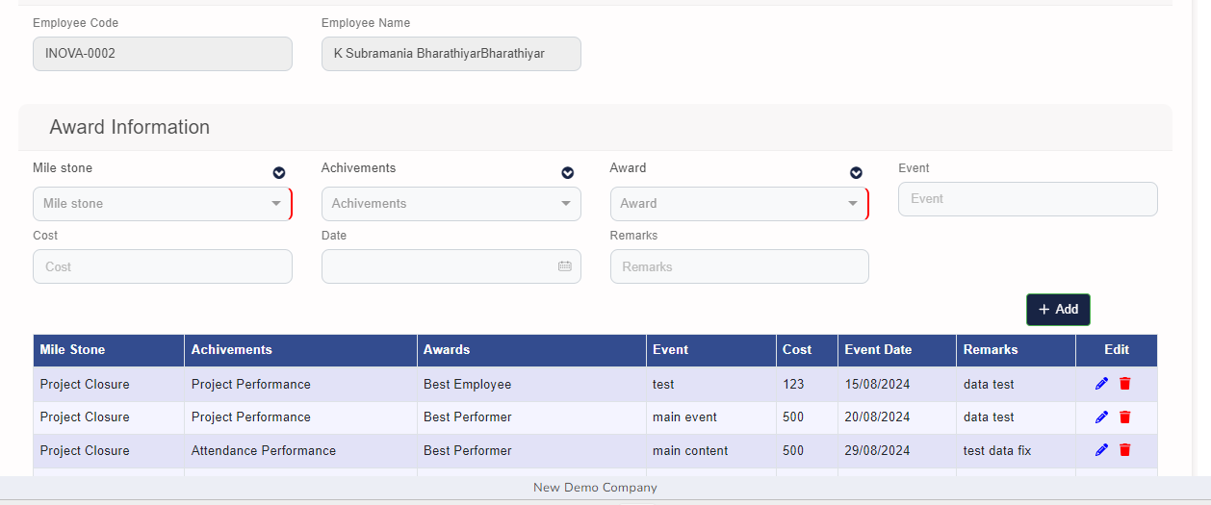
ESS Screen

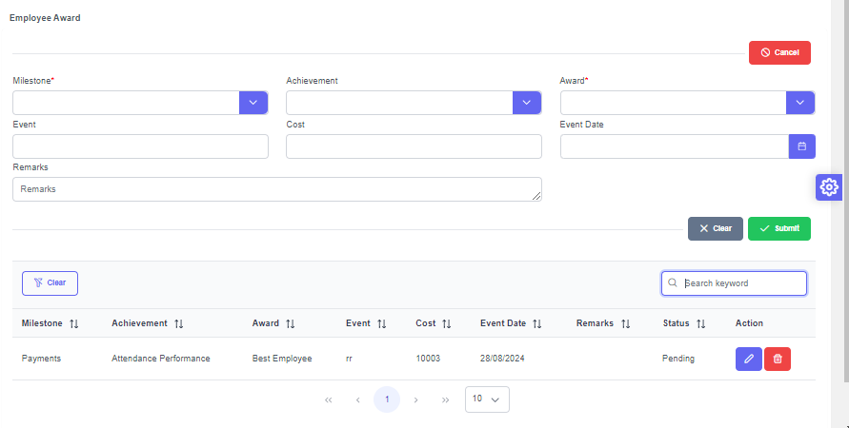
- Search Data is not working
- ESS Request record is not show Back Office Record
- Back office additionally, my entry data for the ESS Portal is not displayed ( At time)
20. Employee Visa
Back office Screen
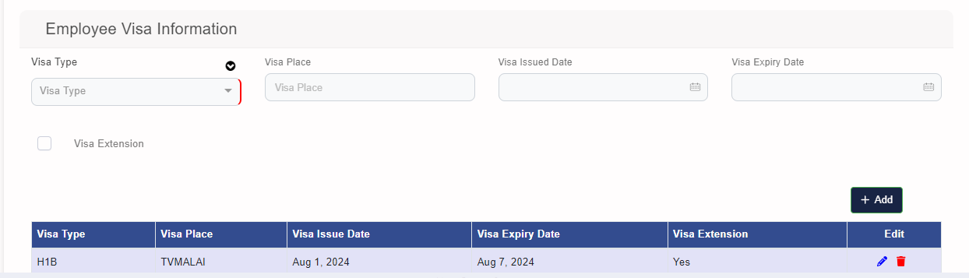
ESS Screen

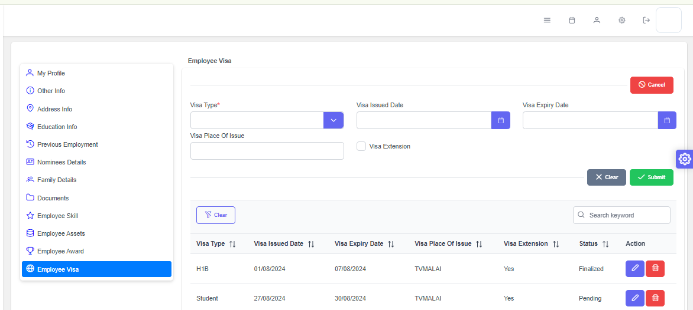

- Delete the Request Record to show the Message your request been sent successfully incorrect
- ESS Request Record is not show the Back Office Screen
- Back office additionally, my entry data for the ESS Portal is not displayed ( At time)

